Dear Homeowner,
This letter is to provide you with notice that the City of Sandy will be performing utility work in the right-of-way (ROW) near or on your property over the next several weeks. This work is one of several upgrades being performed for the City of Sandy’s Water Treatment Plant (WTP). The upcoming work will provide high speed internet connectivity to the plant.
The work being performed includes laying a fiber optic line from Hwy 26 to the plant, and will be installed underground along Whiskey Creek Rd. A contractor has been selected to perform the installation of the fiber optic line, and they are currently slated to begin construction in the next two weeks. Locates have already been called for the sites, and permitting is currently being finalized by Clackamas County. Once those permits are completed, the contractor will begin construction.
To help minimize the disruption to you, the contractor will only work between the times of 9:00am and 5:00pm, Monday to Friday. There will be no after hours, weekend or holiday work performed. The only exception would be in the event of an emergency. All work will be performed underground, using a horizontal directional drill to minimize disruption to the ground.
Below is an overview of the proposed path. All work will be performed on the south side of the road within the Clackamas County ROW.
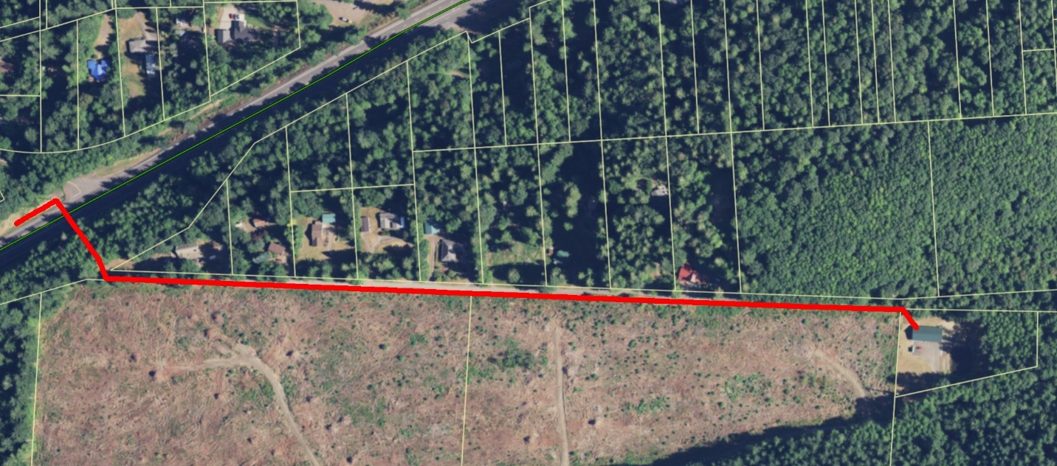
Finally, after the project has been completed, SandyNet will evaluate the area and begin identifying a way to potentially provide the homes on Whiskey Creek Rd. with high-speed broadband. Because the project is primarily for communication connectivity to the WTP, that project must be completed before SandyNet can begin its work.
If you have any questions regarding the proposed construction for the upcoming project, please reach out to Greg Brewster by phone (503)-489-0937 or email at gbrewster@ci.sandy.or.us.

Gregory Brewster
IT Director
City of Sandy
39250 Pioneer Blvd.
Sandy, OR 97055

